Web Technologies Lab
(Lab Task 1)

Name | Fatima Khan.
Registration No | FA24-BCS-033-B.
Submitted To | Sir Usman Akram.
Date of Submission | 17th October 2026.

Lab 1 : Semantic HTML Scaffold
Difficulty: Easy · Covers: Lectures 3–4 · Folder: lab-1/
Before you design your own CV in Assignment 1, practice the raw skeleton: build a semantic HTML5 skeleton (no styling required) for a generic e-commerce homepage — correct <header>, <nav> with at least 4 links, a <main> containing three <section>s (featured products, categories, newsletter signup), and a <footer> with at least three columns of links. Validate your HTML with the W3C Validator and include a screenshot of a clean validation result in your completion PDF.
Deliverables in lab-1/: index.html and your completion PDF.
Code:
Index.html
1. <!DOCTYPE html>
2. <html lang="en">
3. <head>
4. <meta charset="UTF-8">
5. <title>My Shop</title>
6. </head>
7. <body>
8.
9. <header>
10. <h1>My Shop</h1>
11. <nav>
12. <ul>
13. <li><a href="#">Home</a></li>
14. <li><a href="#main_1">Featured Products</a></li>
15. <li><a href="#main_2">Categories</a></li>
16. <li><a href="#main_3">Newsletter</a></li>
17. </ul>
18. </nav>
19. </header>
20.
21. <main>
22.
23. <section id="main_1">
24. <h2>Featured Products</h2>
25. <article>
26. <h3>Product 1</h3>
27. <p>Rs. 1000</p>
28. </article>
29. <article>
30. <h3>Product 2</h3>
31. <p>Rs. 1500</p>
32. </article>
33. <article>
34. <h3>Product 3</h3>
35. <p>Rs. 2000</p>
36. </article>
37. </section>
38.
39. <section id="main_2">
40. <h2>Categories</h2>
41. <ul>
42. <li><a href="#">Clothes</a></li>
43. <li><a href="#">Shoes</a></li>
44. <li><a href="#">Bags</a></li>
45. <li><a href="#">Watches</a></li>
46. </ul>
47. </section>
48.
49. <section id="main_3">
50. <h2>Newsletter Signup</h2>
51. <form>
52. <label for="email">Email:</label>
53. <input type="email" id="email" name="email">
54. <button type="submit">Subscribe</button>
55. </form>
56. </section>
57.
58. </main>
59.
60. <footer>
61. <div>
62. <h3>Shop</h3>
63. <ul>
64. <li><a href="#">New Arrivals</a></li>
65. <li><a href="#">Best Sellers</a></li>
66. <li><a href="#">Sale</a></li>
67. </ul>
68. </div>
69. <div>
70. <h3>Help</h3>
71. <ul>
72. <li><a href="#">Contact Us</a></li>
73. <li><a href="#">Shipping</a></li>
74. <li><a href="#">Returns</a></li>
75. </ul>
76. </div>
77. <div>
78. <h3>About</h3>
79. <ul>
80. <li><a href="#">Our Story</a></li>
81. <li><a href="#">Careers</a></li>
82. <li><a href="#">Privacy Policy</a></li>
83. </ul>
84. </div>
85. <p>2026 My Shop</p>
86. </footer>
87.
88. </body>
89. </html>
90.

Output:

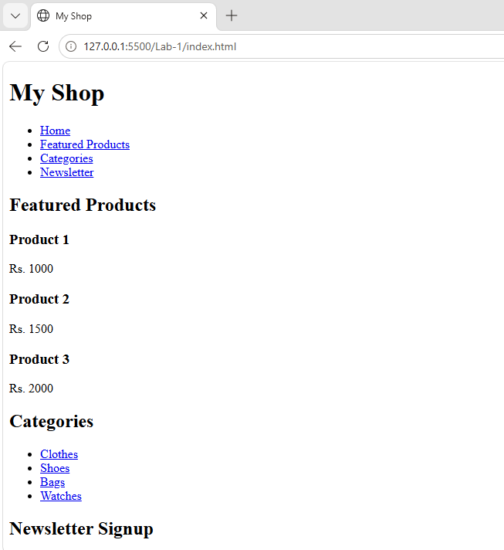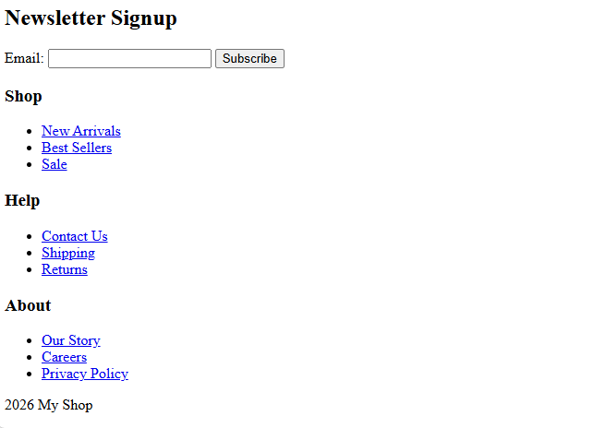
W3C Validator Result

